

The Metreos Application Suite
Customizable IP Telephony Applications for Business

Release 1.0

Administration Guide

Copyright © 2004 Metreos Corporation
All Rights Reserved

Table of Contents

Preface 3
Who should read this guide? 3
The Metreos Application Suite 4
Applications in the Suite 4
Application Suite Configuration 6
Main Configuration Page 6
Main Configuration Page 7
System Management 8
Account Management 10
Create User Account 11
Edit User Account 12
Application Suite Reports 15
Account Summary Reports 16
Call Statistics Reports 17
Security and Access Control Reports 18
Application Configuration 19
Metreos Intercom Configuration 19
Metreos RapidRecord Configuration 21
Metreos ScheduledConference Configuration 22
Metreos ActiveRelay Configuration 23
Appendix 24
Appendix A: Metreos IP Phone Service Installation 24
Preface
No part of this publication may be reproduced, stored in a retrieval system, or transmitted in any form by any means, without written permission from the publisher.

Metreos Corporation makes no representations that the use of its products in the manner described herein will not infringe upon existing or future patent rights, not do the descriptions contained in this publication imply the granting of licenses to make, use, or sell equipment or software in accordance with the description.

Possession, use, or copying of the software described in this publication is authorized only pursuant to a valid written license from Metreos or an authorized sublicensor.

Neither Metreos Corporation not its employees are responsible for any errors that may appear in this publication. The information in this publication is subject to change without notice.

The following are trademarks of Metreos Corporation: Metreos, Metreos Application Suite, Metreos Visual Designer, and the Metreos logo. All other trademarks and service marks are the property of their respective holders.

Who should read this guide?

This document describes the Web interface to the administration and configuration of the various IP telephony applications in the Metreos Application Suite™, and as such is targeted to the communications system administrator. For descriptions of the applications and their usage and operation, please refer to the Metreos Application Suite User Guide.
The Metreos Application Suite
The Metreos Application Suite™ is a collection of the most in-demand voice over IP applications for the enterprise. Each application in the suite is a complete IP telephony application, ready to deploy and run at your site. Since each application is built using Metreos visual tools and executes within the Metreos runtime environment, each is easily and quickly customizable by your staff or integrator, should you wish to do so.

Applications in the Suite
The Metreos Application Suite includes the following IP telephony business applications. The presence of any individual application in your deployment is dependent upon the license in effect.

Metreos VoiceTunnel
Metreos VoiceTunnel™ allows a remote user to connect to any enterprise IP communications system and place calls as if they were local to the system. With Metreos VoiceTunnel, the enterprise can:
- Place all calls locally, avoiding international and long-distance toll charges.
- Authenticate call usage and apply a broad range of policies to the billing and accounting of communications costs.
- Manage, monitor, and report on usage of the communications system.

Metreos ClickToTalk
Metreos ClickToTalk™ is a speed dialing application permitting the calling of any party in a contact list with a single click. Metreos ClickToTalk can be used by anyone in a Cisco CallManager group using a Cisco 7940, 7960, or 7970 IP telephone. A ClickToTalk user might select an entry from his or her Microsoft Outlook contact list, click a button on the Outlook tool bar, and ClickToTalk will dial that contact from that user’s IP phone. Conferencing and recording of calls are also supported.

Metreos ActiveRelay
Metreos ActiveRelay™ permits the placing of calls to any individual using a single number, wherever that individual might physically be located. Metreos ActiveRelay bridges your cellular telephone to your office telephone and rings both simultaneously, allowing you to choose which to answer. Once connected, the call can easily be transferred to other devices configured with ActiveRelay. To the caller, the call sounds like a normal call, and does not exhibit the multiple ring sequences common to older style phone applications in this genre.

Metreos ScheduledConference
Metreos ScheduledConference™ is a Web-scheduled dial-in and dial-out conferencing system. Conferences can be scheduled from an easy-to-use web interface eliminating the need for costly operator or administrative assistance when setting up conference calls. Features include the adding of conference parties, party mute and unmute, and removal of participants from conference.

Metreos Intercom
Metreos Intercom™ permits instant communication over IP phones without the need to dial a number. Lifting the handset, a user selects from a menu the parties to whom they wish to communicate, and audio connectivity is instantly established. Metreos Intercom can be configured to act as a group paging system for the broadcast of voice messages or pages, in the manner of a traditional paging system. Using the TalkBack feature, an intercom listener can press the “Reply” button and conference instantly with each party in the intercom group.

Metreos RapidRecord
Metreos RapidRecord™ automatically records calls placed to and from a configured group of frontline devices, permitting seamless, hands-off call recording. Calls so recorded may be played back either from a Web interface, or directly from the IP phone that placed or received the call. Since all calls are recorded, businesses can avoid the problem common to other applications in this genre, that of missing call content occurring prior to the time recording could be enabled.

Application Suite Configuration

The communications system administrator, hereafter you, performs remote configuration of and reporting for the Metreos Application Suite via the Application Suite Administration Console.

The Administration Console includes facilities for the configurations of all applications in the suite, both individually and as a group, and provides easy access to a comprehensive set of reporting and accounting functions.

Before You Begin
Since each application in the Metreos Application Suite runs in the context of the Metreos runtime environment, you should have performed basic Metreos Application Server configuration prior to running reports and applications in the suite.

Login
Upon navigating to the administration URL, http://yourserver/appsuiteadmin/, the administrator is presented with the password page as shown in Figure 1. The user name and password will initially be set to defaults, currently administrator/metreos. The administrator will have the opportunity to change this password on ensuing pages.

Once logged in, you can access all configuration and reporting options of the Metreos Application Suite.

Figure 1: Application Suite Login

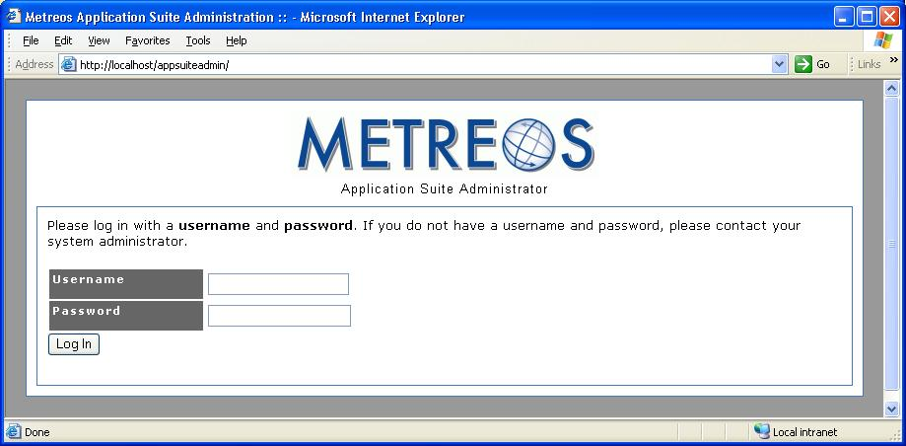

Main Configuration Page

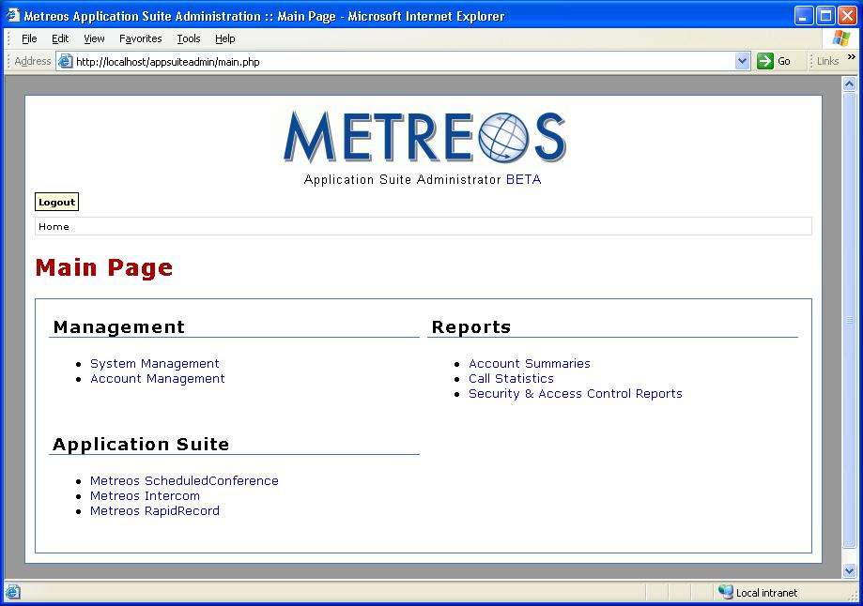
Figure 2: Main Configuration Page

From the main configuration page (Figure 2), you can navigate to all configuration and reporting options of the management console.

System Management
System management facilities include password maintenance and server name specification.

Account Management
Account management facilities permit the establishment and maintenance of application user accounts.

Account Summary Reports
Account summary reports display call statistics by user, optionally filtered.

Call Statistics Reports
Call statistics reports show call details filtered by various criteria such as application.

Security and Access Control Reports
Security reports detail security and access violations by device.

System Management
Selecting System Management from the main configuration page elicits the System Management page, as shown in Figure 3.

Figure 3: System Management
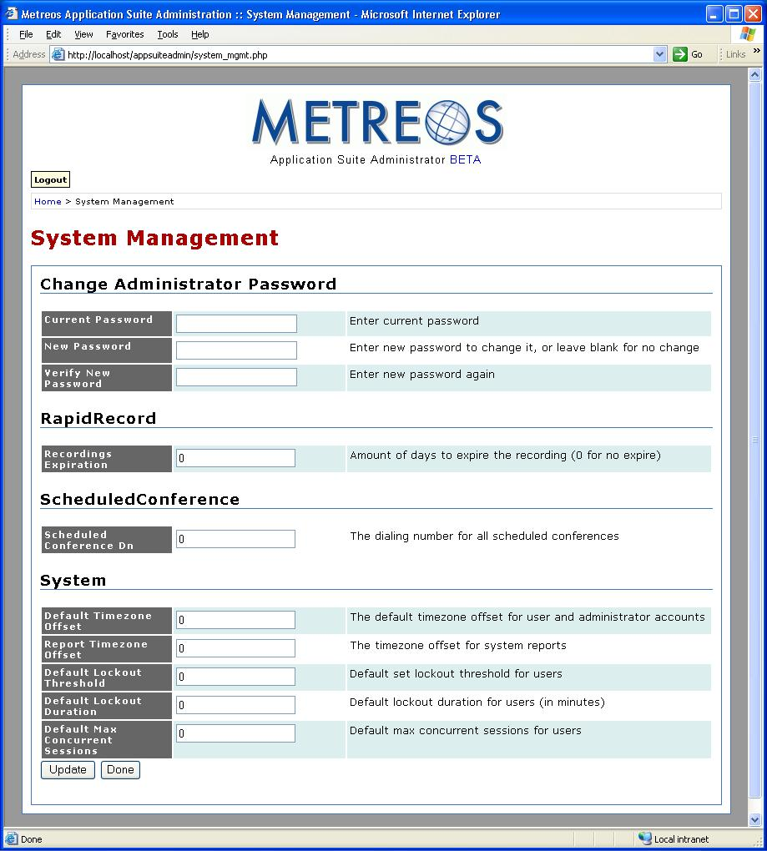

The following functionality is available on the System Management page:
- Change administrator password
- Metreos RapidRecord configuration
- Metreos ScheduledConference configuration
- System configuration

Change Administrator Password
To change the administrator password, enter both your current password and your new password in the box provided. Re-enter the new password in the indicated box, for verification.

RapidRecord
In the box labeled Recordings Expiration, enter the number days that a voice recording should be kept on disk. An entry of zero indicates that recordings do not automatically expire, and must be manually deleted.

ScheduledConference
In the box labeled Scheduled Conference DN, enter the number that a user will dial to schedule a conference using the Metreos ScheduledConfererence application.

System
- Default Time Zone Offset
Enter the offset from GMT, positive, negative, or zero, to be used for any account which does not specify an offset.
- Report Time Zone Offset
Enter the offset from GMT, positive, negative, or zero, to be used for calculation of time stamps in system reports.
- Default Lockout Threshold
Enter the number of consecutive failed logins before an account is locked from further login attempts, to be used when not overridden for an individual account.
- Default Lockout Duration
Enter the length of time that an account remains locked, to be used when not overridden for an individual account.
- Default Max Concurrent Sessions
Enter the maximum number of sessions which a user account may have active concurrently, to be used when not overridden for an individual account.

Account Management

Selecting Account Management from the main configuration page elicits the Account Management page, as shown in Figure 4.
Figure 4: Account Management
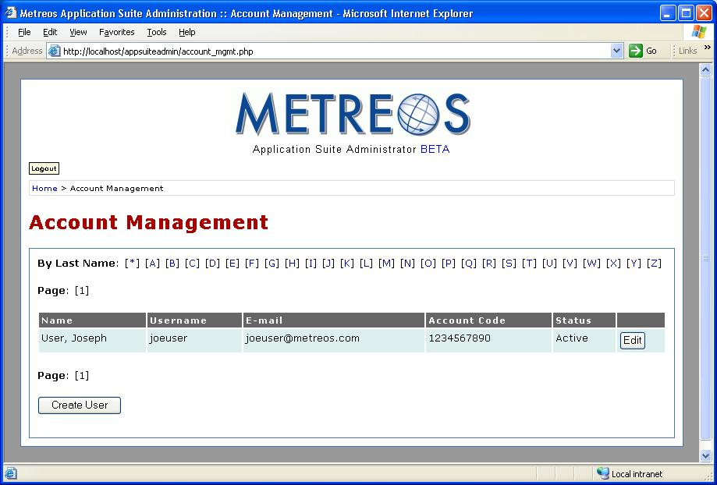

Functionality available on the Account Management page is:
- Create User Account
- Edit User Account

Create User Account
To create a new Metreos Application Suite user account, click the button labeled Create User. This elicits an empty Edit User Account screen, the operation of which is described in the next section.

Edit User Account
To make changes to an existing Metreos Application Suite user account, click the button labeled Edit found at the end of the screen line containing the name of the user you wish to change. A populated Edit User Account screen is displayed, the operation of which is described in the next section.

Create User Account

Selecting the Create User button from the Account Management page elicits the Create User Account page, as shown in Figure 5.

Entering Account Information (New or Change)
Complete the fields as described following for the new account. Note that these field descriptions also apply when changing information for an existing account.

Account Properties

First Name, Last Name
Enter the name by which this user of the Metreos Application Suite wishes to be known.

Email Address
Enter the email address at which this wishes to receive Application Suite notifications.

Change Password, Verify Password
Enter the password with which this user will be authenticated by each application. Re-enter the password in the Verify Password box. If you are changing an existing account, and the password is not changing, leave these entries blank.

Account Code
Enter the account number with which this user of the Metreos Application Suite will be identified and authenticated.

Change PIN/Verify PIN
Enter the Personal Identification Number with which this user of the Metreos Application Suite will be identified and authenticated. A PIN should consist of 3 or 4 digits.

Status
Select the account status for this user account, using the supplied dropdown. Accounts may be inactivated and reactivated here.

Time Zone Offset from GMT
Enter the difference in hours by which this user’s local time differs from Greenwich Mean Time. This entry may be positive or negative.

Lockout Threshold, Lockout Duration
In Lockout Threshold, enter the number of times this user may have his or her Metreos Application Suite login rejected, before the account is forced into a locked state and this user is prevented from making further login attempts. In Lockout Duration, enter the number of hours and minutes the account will subsequently remain locked. If no entry is supplied for Lockout Duration, the Metreos Application Suite will not automatically unlock a locked account, requiring that the administrator manually unlock the account.

Failed Logins, Concurrent Logins
These entries are set by the Metreos Application Suite, indicating the number of times this account has experienced failed login attempts, and the number of times the account has attempted to log in while already logged in, respectively. You can reset either of these entries to zero using the button labeled Reset, found to the right of each entry.

PIN Change
Checking the required radio button here indicates that the user must change his or her PIN at the next login. This feature is normally used when the PIN is set to some default value when the account is first created, to indicate that the new user must change PIN at first use of the Application Suite.

External Authentication
Checking the required radio button here indicates that authentication of this user will be deferred to the configured LDAP directory.

Record Calls/Recordings Visible
Checking the Record Calls box here requests that all calls initiated by this account are to be recorded. Checking Recordings Visible indicates the user’s phone display will show that the call is begin recorded, displaying a button with which the recording can be stopped and restarted.

The Metreos RapidRecord application must be configured for this user in order to record calls. Refer to Metreos RapidRecord Configuration on page 30 of this document for more information.

Edit User Account

Selecting the Edit button from an account record on the Account Management page elicits the Edit User Account page. This page is similar to the new account page as shown in Figure 5, with the addition of Devices and External Numbers. See Figure 6 on page 20 for an illustration of these additional fields.

Entering Account Information
Enter any changes to the account record as described in the previous section. Enter any devices, such as telephones, which are to be associated with the account, and enter the numbers at which the account can be reached.

Devices
In the Devices section are entered the various telephones at which this user can be reached.

For each telephone device, enter a friendly name for the device, such as “office” or “home”, plus its MAC address (network interface card address). The MAC address of the phone can generally be obtained via an option on the telephone’s menu display.

For the single device to be assumed to be the user’s primary telephone, press the button labeled Set Primary, located at the end of line containing the device information.

Finally, as you add devices, you will have the opportunity to add line numbers which are to be associated with the device.

External Numbers
In the External Numbers section are entered the various telephone numbers at which this user can be reached.

For each device, enter a friendly name for the device, such as “pager” or “mobile”, along with its dialing number.

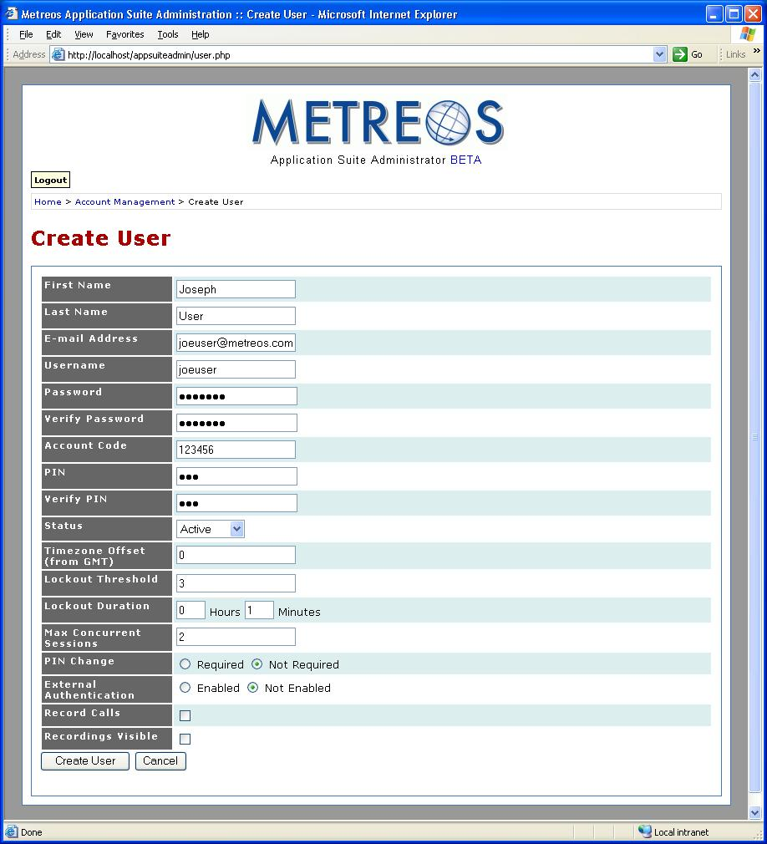
Figure 5: Create User Account
Figure 6: Edit User Account
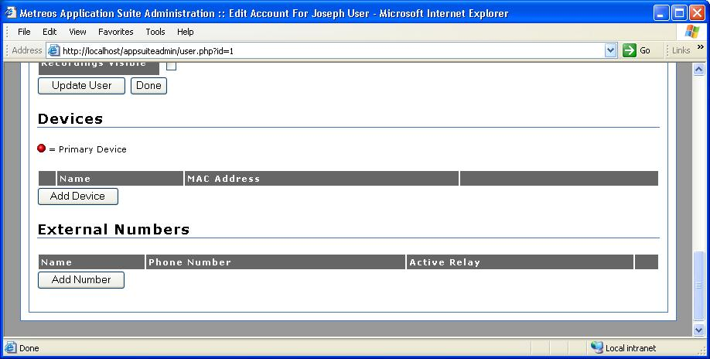

Application Suite Reports

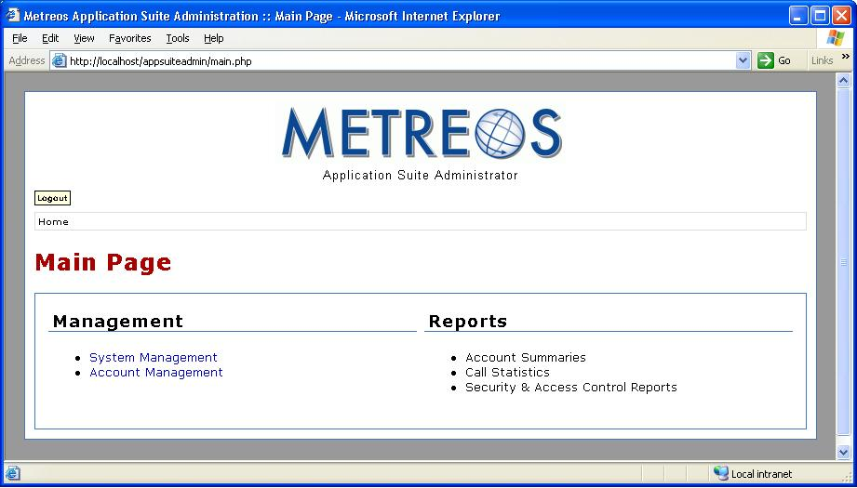
Figure 7: Main Configuration Page

The Metreos Application Suite reporting facility permits the accumulation and presentation of statistics and metrics pertaining to the account usage of each application in the suite. Reported statistics are commonly used for billing calls, detecting intrusion, and maintaining a record of customer contacts. All such administration reports may be accessed from the main administration page. The available reports are:

Account Summaries
The Account Summary reports show calls by account code, filtered by selected criteria.

Call Statistics
The Call Statistics reports show calls placed to selected clients, and associated with selected projects.

Security and Access Control
The Security and Access Control reports show statistics on each device accessing each account.

Account Summary Reports

The Account Summary reports present statistics for each account code, such as cumulative call duration, average call length, and more. The filtering criteria found at the top of the report page lets you show only accounts which exceed a specified threshold for any of the available metrics, or to quickly access statistics for any selected account code.

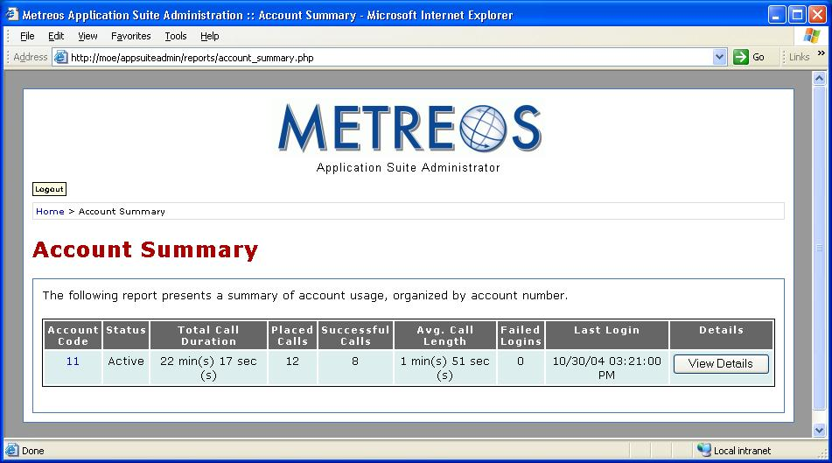

Call Statistics Reports

The Call Statistics reports show statistics reflecting calls placed from selected accounts, to particular clients, and associated with selected projects. The filtering criteria found at the top of the report page lets you show only accounts which communicated with a particular client, or which made calls billable to a selected project.

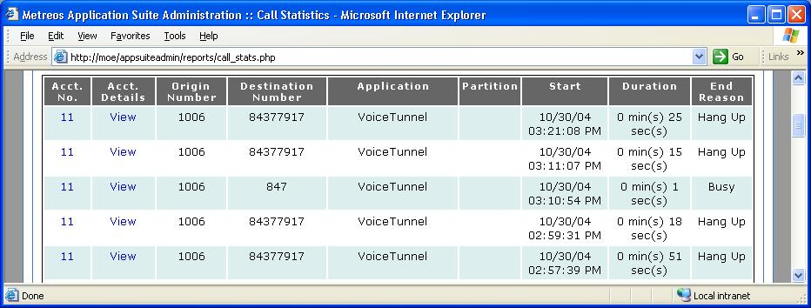

Security and Access Control Reports

The Security and Access Control reports display detailed information on which devices are using which account codes. In the event of an account lockout or an unexpected ‘concurrent sessions exceeded’ error, this page can be used to determine the device which made the offending login attempt or which was logged in illegitimately. The filter criterion at the top of the page provides an easy way to view the access records for particular accounts, or to see which accounts a particular device is accessing.

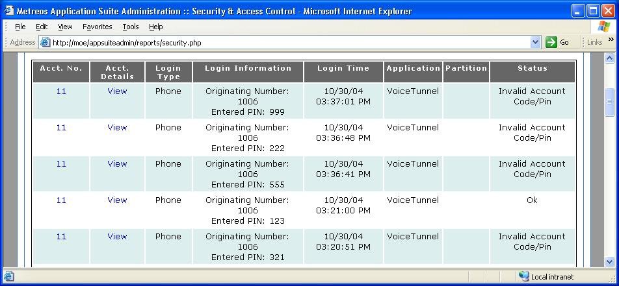

.

Application Configuration

Individual applications in the Metreos Application Suite may require installation and configuration by the administrator. Cisco CallManager may require application-specific configuration, participant groups may need to be created, et cetera.

Metreos Intercom Configuration

Metreos Intercom™ permits instant communication over IP phones without the need to dial a number. Lifting the handset, a user selects from a menu the parties to whom they wish to communicate, and audio connectivity is instantly established. Metreos Intercom can be configured to act as a group paging system for the broadcast of voice messages or pages, in the manner of a traditional paging system.

To configure the Metreos Intercom application, you will need to:
- create intercom groups, and
- install the IP phone service.

Metreos Intercom uses the concept of an intercom group. To broadcast a Metreos Intercom message, a user selects on his or her IP phone display an intercom group to which he or she wishes to talk, speaks normally without lifting the handset, and the voice message is broadcast to the phone speaker of each member of the group. Intercom groups can only be created by the administrator. If the administrator has defined the group to be public, anyone can join or leave the group once it has been created. If the group is private, its membership is determined solely by the administrator.

Figure 8: Intercom Groups Page
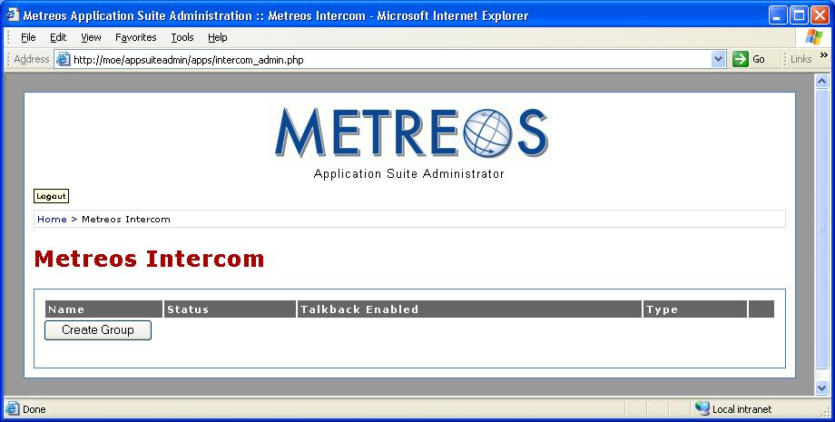

Creating an Intercom Group
In order for users to broadcast or hear a voice messages over Metreos Intercom, each such user must be a member of the intercom group selected for broadcast

To create an intercom group, select Metreos Intercom from the main administration page. You will be presented with the Metreos Intercom page, as shown in Figure 8 on page 26. From there click the button labeled Create Group. The Create Intercom Group page is displayed, as shown in Figure 9.

Figure 9: Create Intercom Group
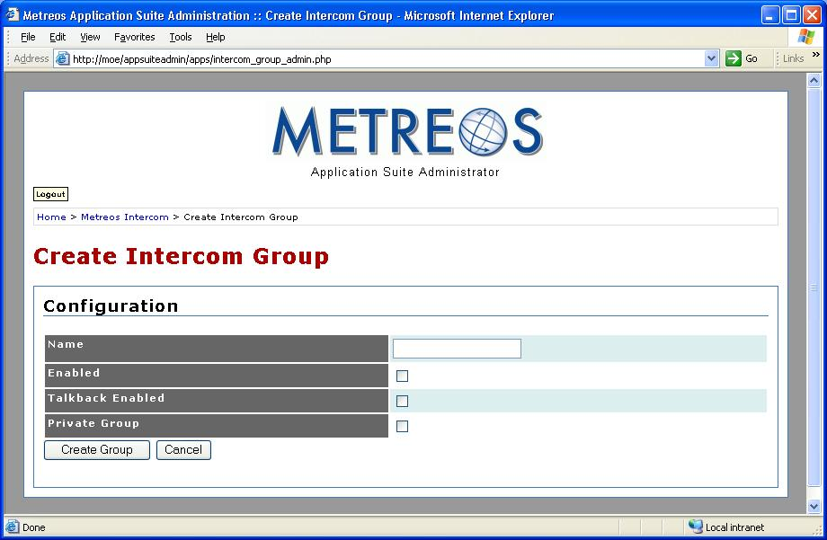

On the Create Intercom Group page, enter the name you wish to use for the group. Check whether you wish for the non-initiating members of the group to be able to talk back over the intercom channel, and whether this is a private group. Click Create Group and the group is ready to participate in Metreos Intercom.

Configuring the Metreos Intercom Cisco IP Phone Service
Before Metreos Intercom can be used, the phone service must be installed on CallManager, and the participating phones subscribed to the service. To do so, follow the instructions in Appendix A: Metreos IP Phone Service Installation on page 33. Note that when following these installation instructions, that the Metreos Intercom triggering script name is LaunchIntercom.

Metreos RapidRecord Configuration

Metreos RapidRecord™ automatically records calls placed to and from a configured group of telephones, permitting seamless, hands-off call recording. Calls so recorded may be played back either from a Web interface, or directly from the IP phone that placed or received the call.

Configuration instructions for Metreos RapidRecord were not available by the publishing deadline. An update to this document will be sent to you soon containing this information.

Metreos ScheduledConference Configuration

Metreos ScheduledConference™ is a Web-scheduled dial-in and dial-out conferencing system. Conferences can be scheduled from an easy-to-use web interface eliminating the need for costly operator or administrative assistance when setting up conference calls. Features include the adding of conference parties, party mute and unmute, and removal of participants from conference.

Configuration instructions for Metreos ScheduledConference were not available by the publishing deadline. An update to this document will be sent to you soon containing this information.

Metreos ActiveRelay Configuration

Metreos ActiveRelay™ permits the placing of calls to any individual using a single number, wherever that individual might physically be located. Metreos ActiveRelay bridges your cellular telephone to your office telephone and rings both simultaneously, allowing you to choose which to answer. Once connected, the call can easily be transferred to other devices configured with ActiveRelay. To the caller, the call sounds like a normal call, and does not exhibit the multiple ring sequences common to older style phone applications in this genre.

Configuring the Metreos ActiveRelay Cisco IP Phone Service
Before Metreos ActiveRelay can be used, the phone service must be installed on CallManager, and the participating phones subscribed to the service. To do so, follow the instructions in Appendix A: Metreos IP Phone Service Installation on page 33. Note that when following these installation instructions, that the Metreos ActiveRelay triggering script name is ActiveRelay.

Once the phone service is installed, each telephone which is to be the recipient of ActiveRelay calls must be subscribed to the service, also as outlined in Appendix A.

Appendix

Appendix A: Metreos IP Phone Service Installation

For any Metreos Application Suite application which utilizes a Cisco IP Phone Service, the administrator must install the Metreos IP phone service on Cisco CallManager for that application. This section describes the general procedure for installing a Metreos phone service. Installation and configuration issues specific to an individual application will be described in the section of this document dealing with that application.

Determining the Metreos Application URL
Before you add the phone service, you will need to have at hand the URL of the Metreos Application Suite application for which you are installing the service; that is, the URL which when recognized by the Metreos runtime environment, triggers the application.

From the MCE Administration Console, under Components, select Applications. The Applications page is presented. From there, select the appropriate application. The application configuration page for the selected application is displayed. At the bottom of this page is found the Partitions section. Click the button labeled Edit next to the default partition. The partition configuration page is displayed.

In the Scripts section of this page will be listed one or more application scripts. In this section, find the applications primary script (as documented in the section of this document dealing with the installation and configuration of that specific application). The Trigger Parameters entry for this script will show a parameter named URL. The value of the URL parameter will be a text string beginning with a slash character. This is the value which you will supply to CallManager as the triggering URL in the next section.

Installing the IP Phone Service
From the Cisco CallManager Administration console, select Feature from the main menu, then select Cisco IP Phone Services from the ensuing dropdown menu. The Find and List IP Phone Services page is displayed. From this page click the link labeled Add a New IP Phone Service. The Cisco IP Phone Services Configuration page is displayed. Enter a name and a description for the service in the boxes provided.

In the box labeled Service URL, you will enter the Metreos runtime IP address, followed by the triggering URL parameter you located in the previous section, followed by the string ?device=#DEVICENAME#. For example, if the Metreos runtime URL is as shown, and the application triggering URL is /LaunchIntercom, you will enter:
http://192.168.1.126:8000/ShowIntercomGroups?device=#DEVICENAME#

Finally, press the button labeled Insert to install the IP Phone service.

Associating Phones with the Phone Service
For each phone expected to participate in the application, you will subscribe it to the IP phone service. From the Cisco CallManager Administration console, select Device from the main menu, and then select Phone from the ensuing dropdown menu. The Find and List Phones page is displayed. Look up the phone in question using the Find button on this page. When the search completes and the phone (or phones) is/are displayed, click on the phone in question. The Phone Configuration page is displayed. From this page click Subscribe/Unsubscribe Services, found in the upper right corner. The Subscribe Cisco IP Phone Service page is displayed for this phone.

In the box labeled Select a Service, select the IP phone service in question from the dropdown, and press Continue. The Service Subscription page is displayed. Click the button labeled Subscribe. This phone is now subscribed to the service.

Filtering Criteria and Download options may not be available in the initial release.
Filtering Criteria and Download options may not be available in the initial release.
Filtering Criteria and Download options may not be available in the initial release.

